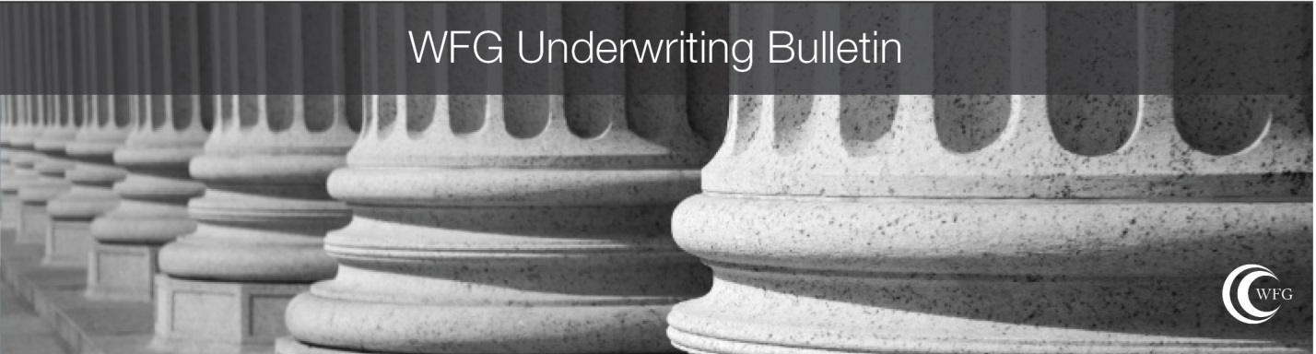

To: All WFG Policy issuing agents in Nevada
From: Underwriting Department
Date: January 16, 2020
Bulletin No. NV 2020-01
Subject: Nevada Rate Filing effective November 1, 2019

Please be advised that the Nevada Department of Insurance has recently approved WFG’s new rate filing effective Friday, November 1, 2019.

The complete rate manual may be found here: https://wfgunderwriting.com/nevada/rate-manuals

It has come to our attention that our original distribution in October of 2019 may not have been all-inclusive and received by all parties involved.

If you should have any questions or concerns, please contact your local management or WFG Agency Support.

If you have any specific questions about the content of this manual, please contact rwilliams@wfgnationaltitle.com.

NOTE: This Bulletin is for the sole purpose of establishing underwriting positions and policies reflecting WFG National Title Insurance Company’s best business judgment. The information contained in this Bulletin is intended solely for the use of employees of WFG National Title Insurance Company, its title insurance agents and approved attorneys. Disclosure to any other person is expressly prohibited unless approved in writing by the WFG National Title Insurance Company’s Underwriting Department.
The Agent may be held responsible for any loss sustained as a result of the failure to follow the standards set forth above.

